



**SM6P07NI Digital Media Project**

**20% Research and Proposal**

**2022-23 Winter**

**Student Name: Ashraya Singh Khatri**

**London Met ID: 19031980**

**College ID: NP01MM4A190077**

**External Supervisor: Pooja Shrestha**

**Internal Supervisor Rakshak Bhushan Bajracharya**

**Assignment Due Date: Wednesday, December 28, 2022**

**Assignment Submission Date: Wednesday, December 28, 2022**

**Word Count: 2954**

*I confirm that I understand my coursework needs to be submitted online via Google Classroom under the relevant module page before the deadline in order for my assignment to be accepted and marked. I am fully aware that late submissions will be treated as non-submission and a marks of zero will be awarded.*

**Abstract**

This documentation gives a brief overview of the research and development aspect of the project for Digital Media Project (DMP). The content of this document provides a thorough explanation to the topic of the DMP, i.e., Low Poly Game Assets. It further explains the use of low poly modelling by indie game developers and it’s rise in the video game industry.

In the field of gaming industry and 3D animation low poly modelling has been an art from the very beginning since low polygonal resolution helps to reduce the render time and greatly speeds up the processing time to model the characters and props. Indie game developers these days mostly choose to create a game with low poly art has it gives them more time to model them and aren’t bothered by deadlines. Artists love to create their own 3D world, but not everyone knows how to model, so they download pre-made assets from resources like Unity or Synty studios. By using these assets, they can customize their scenes as they want and focus on other aspects like lightning, compositing, as can work on their work.

The following documentation contains the research to create a low poly stylized asset used for games. With the help of my supervisors, Rakshak Sir and Pooja Ma’am, I was able to finalize my concepts. My concept for DMP is to create low poly animations and models as assets to be used in-game development. This project will showcase all the research, and software to complete the project.

Contents

Introduction 1

1.1 Topic 1

1.2 Area of Research 2

2. Aims of Project 3

3. Target Audience 4

3.1 Primary Target Audience: Game Designers/ Indie Artist 4

3.2 Secondary Target Audience: Gamers 4

4. Product Research 5

5. Technologies employed 6

6. Project Plan 7

Changes in the Plan 8

7. Production Phases 8

Game development Life Cycle 8

8 Resources 10

**Table of Figures**

# Introduction

This document carries a brief overview of the second coursework for the module “Digital Media Project (SM6P07NI)”. The course covers 20% of the total assessment weight. For this semester the students are required to complete their individual projects and provide their internal and external supervisors the documentation which should contain overall production process, evidence, and testing of the project. The documentation aims to cover all the research and work put as an individual to create game assets for games. It further covers the target audience, the software used, and the resources and techniques used to complete the project.

## 1.1 Topic

**“Stylized Low Poly Assets Packs**”

The topic for the project was inspired by numerous low poly asset packs which were being placed up by Asset artist who were creating amazing and entertaining looking assets for people to enjoy. The whole idea for the project is to provide numerous asset packs to people as they can customize their own games by using this pre-made models.

The final products contain 8 different asset packs that can be used for different gaming scenarios and environment. The assets pack contains from low poly campfire up to space rockets. As shown in the above figure, we can see all the stylized asset packs.

## 1.2 Area of Research

The field of game industry is a very vast one. So, the amount of research and creativity is a very large one as well. Form modelling, lightning, texturing, to worldbuilding these topics had to be properly researched before starting the project. Firstly, I researched reference for the modeling.

After I properly researched and used the reference for modeling and started the process. Since, my shading is stylized low poly I began researching and collecting references for it as well. Thus, the research for modeling includes witch’s brew, dungeons, rockets, etc. In addition to the modelling, I wanted to provide animation loop for user could use in their required scenario.

As to further stylize the assets of specific shader there had to be followed to specific modeling with low sculpting and lightning to give it that look. After all the assets and textures that was created for the project were assembled in Blender. Therefore, there was extensive research for the use of the software with proper knowledge of lightning, texturing, shader setup.

# 2. Aims of Project

The aim of the project is to simply create a low poly asset pack for the user, as it would lessen their production time and they will be able to finish their project in a faster and efficient way. As there so many assets available throughout the internet this not only helps the user to save their time and increase their productivity, it also allows other who don’t have skills in the field of 3D and want to engage in it. The process of creating assets includes concept art, references, storyboarding, modelling mapping, UV baking, texturing, shading, lightning and compositing. So, there are many processes out there in the field of 3D. It is very vast and needs a deep level of creativity and understanding which might be time consuming and hard for many. Thus, the market of assets being available as a valuable research are very growing in the video game industry.

The low poly stylized asset contains various modular meshes, pieces from campfire, car loop animation to weapon packs. Using this asset, the user can easily customize their gaming environment without giving more attention to modelling. Indie game developers mostly dabble in low poly as it is cost effective and easier to make a game on. This pack which is stylized and simple can be personally customized and be used as a resource in their games.

In conclusion, the main objective of this asset pack is to help the game developers and those who wish to learn and use more 3D as a stylized game packs which can be easily usable. I hope that the project will also be able to inspire more people to learn and try 3D modelling and create their own enjoyable and creative assets.

# 3. Target Audience

## 3.1 Primary Target Audience: Game Designers/ Indie Artist

**Age:** 15 + above

**Gender:** All genders

**Ethnicity:** All Ethnic group of people

**Location:** Throughout the world

**Genre Specification:** Stylized Low Poly

As the process of creating asset is time consuming and leads to being hectic at times. The process of creating assets can be prove useful for them as they can be used for building their own games.

## 3.2 Secondary Target Audience: Gamers

**Age:** 15 + above

**Gender:** All genders

**Ethnicity:** All Ethnic group of people

**Location:** Throughout the world

**Genre Specification:** Stylized Low Poly

As there are gamers or viewers who want to use different 3D modelling software that want to customize the games. In gaming Industry modification of a game is very popular. Gamers can use the assets and customize the games as their choice and release it in the market.

# 4. Product Research

While researching the contents for my DMP, I came across a new software that was not taught to us here in college. I used Blender to complete my project, and I acquired many new tools and techniques from there which I have employed in my project.

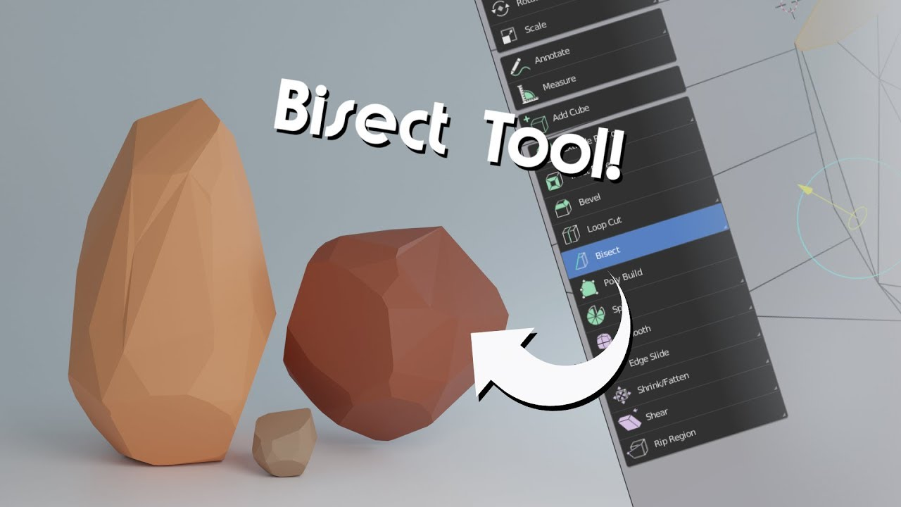

As I started Blender, I leaned many new tools and techniques. One of the common tools that I used to make low poly stones is Bisect tool. It helps in a quick way to cut a mesh in two along a common line.

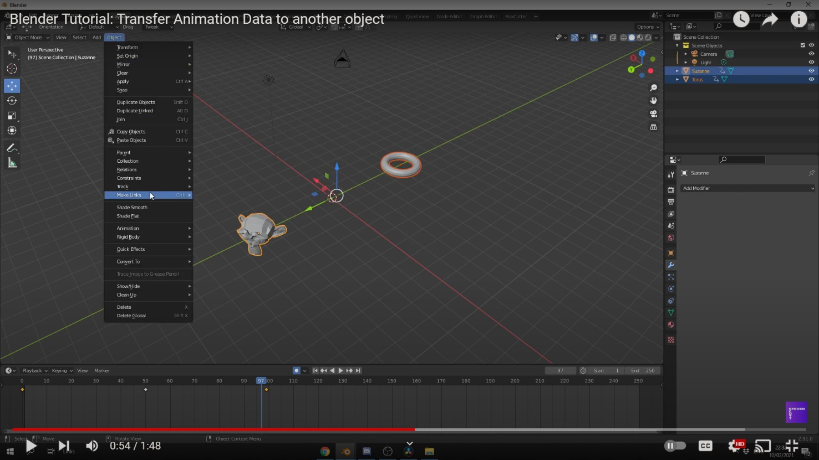

Since, I am also making short animation loops. I learned how to copy and transfer animation data from one object to another. Linking transfers animation data from one mesh to another. The animation data is now linked, changing the animation data in one object also changes the animation on the other.

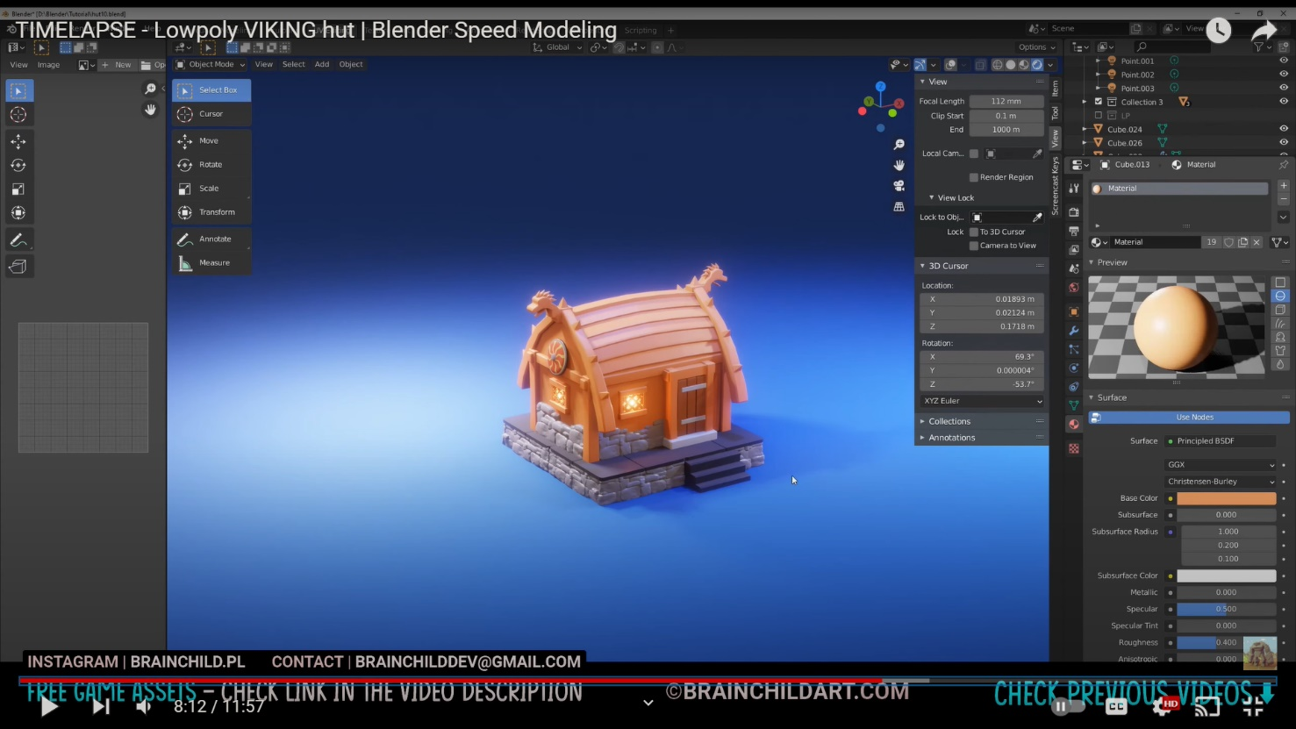

In Blender, materials are the objects that are generated with color, pattern and texture. Shader Editor can be accessed through the Shading tab. The preview is shown on the top screen, while the Shader Editor is shown at the bottom.

# 

If after selecting an object if nothing appears, then then the object lacks material. After clicking the new “+” button at the bottom of screen, a Material is created and a node is automatically created.

The note must be attached is the Material Output node. This node’s connection will be reflected. The default shader is Principal BDSF. The default shader should be disconnected, and after creating another node, drag a line from “BDSF” on the right side of the required node to the material output.

# 5. Technologies employed

Many types of software were utilized to finish the project. These software were used for modeling, texturing, lighting, and compositing.

* Blender

This software will be used for all of my modeling and animation

* Adobe Illustrator

This software will be used for vector designs for the project

* Adobe After Effects

This software will be used for editing the final video

* Adobe Premiere Pro

This software will be used for compositing and color correcting the final video

* Substance Painter:

This software will be used for importing and exporting textures for my models

# 6. Project Plan

Gantt chart

To show the production of my project plan I have created a Gantt chart which displays the overall workflow of the project. All the steps, including modeling, texturing, compositing is further clarified.

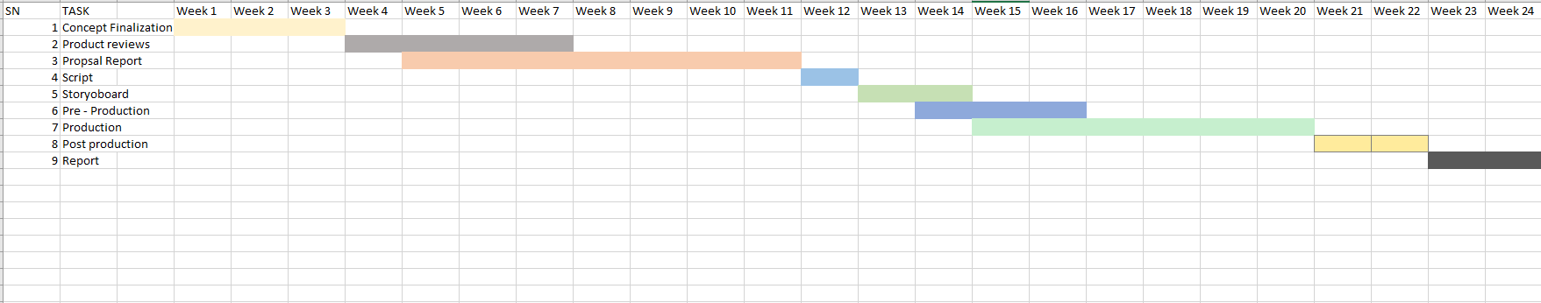

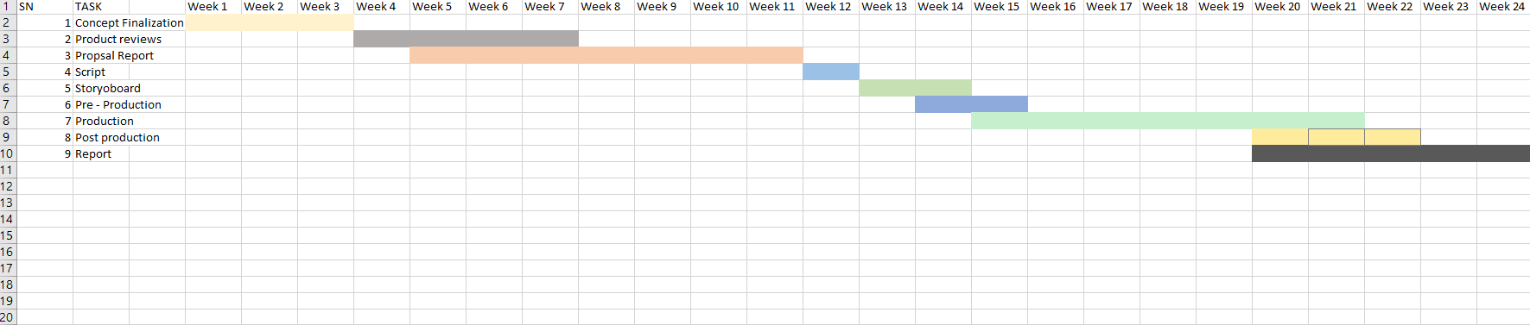

The initial plan that was done for the DMP was updated with the new Gantt chart. The production phase duration has increased giving more time to create models with proper shaders and lightning. Post-Production has been moved forward as to render the materials as quickly as possible.

## Changes in the Plan

In the early stages, the project was going smoothly. But, with the encounter with some software bugs the project was halted for a while. The project contained modelling and animation loops, and I decided to add some particle effects to make it more appealing. So, due to some technical problems and understanding new topics made it time consuming. Thus, the contents and scheduling for the production and prost- production process were updated to match the changes.

# 7. Production Phases

## Game development Life Cycle

Game Development Life Cycle also known as GDLC is a life cycle of software development with the aim to help the developers follow specific plans to achieve their desired products. Comparing to Software Development Life Cycle (SDLC), developers may face many obstacles while developing games, hence they follow a specific set of planning for developing games.

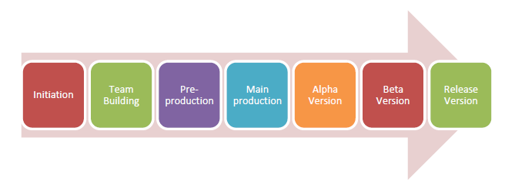

When the game is being released to the general public, GDLC goes through seven different stages, as shown in the above image. The stages are as follows: Firstly, planning what game to produce, deciding on the genre of the game, pre-production: which includes building the

games prototype. The main production includes the games latest version. The alpha version is the unfinished but playable game which is used for alpha testing and fixing bugs and errors. The Beta version is when the game is being tested out by beta tester and released once the bugs are found by the testers and errors have been fixed.

Pre- Production

# 8 Resources

8.1 Hardware and Devices

• Acer Predator Helios 300

• NVIDIA GTX 1650TI GPU

• Intel Core7 9th Gen

8.2 Software

A total of 5 different software was used in the production of this project. All of these software were used for modeling, texturing, lighting, and compositing.

❖ Adobe Photoshop 2021

❖ Adobe Illustrator 2021

❖ Blender 3.4

❖ Substance Painter

❖ Adobe After Effects 2021